**­­­IT 5434 Network Security Fundamentals**

**Lab Assignment 10 (L10)**

**60 points**

**Due: see due date under Dropbox on Folio**

**Student Name: Emmanuel Opara**

**Eagle ID:901305850**

**FTPS (FTP over SSL/TLS) using FileZilla Server and Client on Windows**

Prepared by Dr. Lei Chen

This document guides you through the steps for setting up a **FileZilla Server** and **Client** using **FTPS** (**FTP over SSL/TLS**, one of the three popular secure file transfer protocols: FTPS, SFTP and SCP) on a Windows platform. By completing these steps, you should be able to transfer files in a secure way between a FileZilla server and a client (although they run on the same computer, or local host or 127.0.0.1).

1. Go to <https://filezilla-project.org/download.php?type=server>, download and install (using the default settings) the latest version of FileZilla Server for Windows. Configure the server as follows.
   1. Under “FTP Server” then “Security”, use a self-signed X.509 certificate. If no existing certificate exists, then generate one and use it. Paste screenshot.

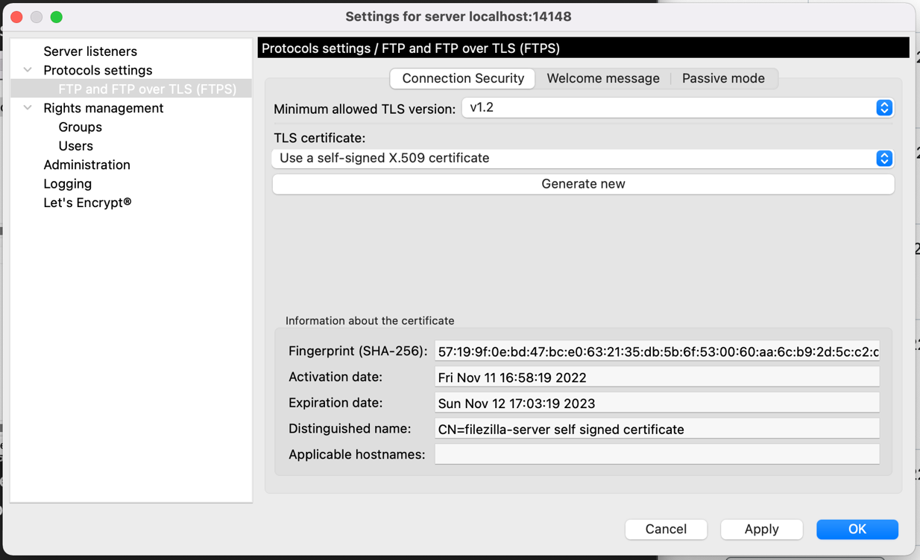

* 1. Under “Administration” then “Security”, use similar settings but the fingerprint of the certificate should be different from that of the one in step 2.a. Paste screenshot.

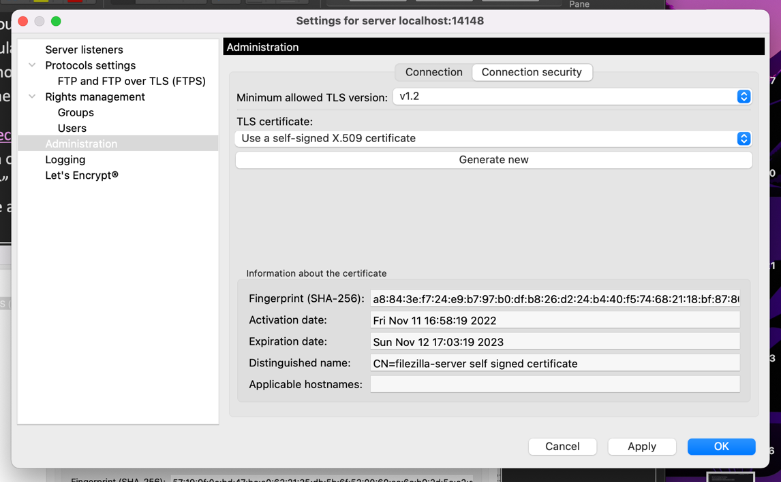

* 1. Under “Groups”, create a new group “IT5434”.

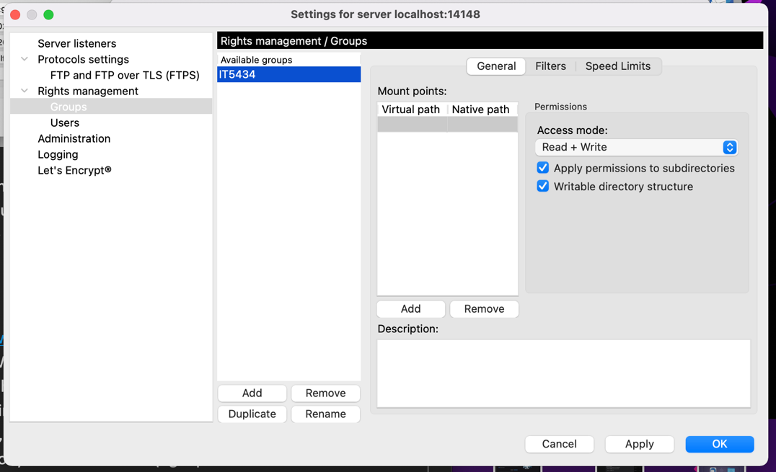

* 1. Under “Users”, create a new user with your first name, e.g., “Lei”. Set a password for the user and set the user as a member of group IT5434. Your Mount points should go as follows: Virtual Path should be “/”, Native path should be something like “C:\Users\Lei\Downloads” replacing “Lei” with your username. Paste screenshot.

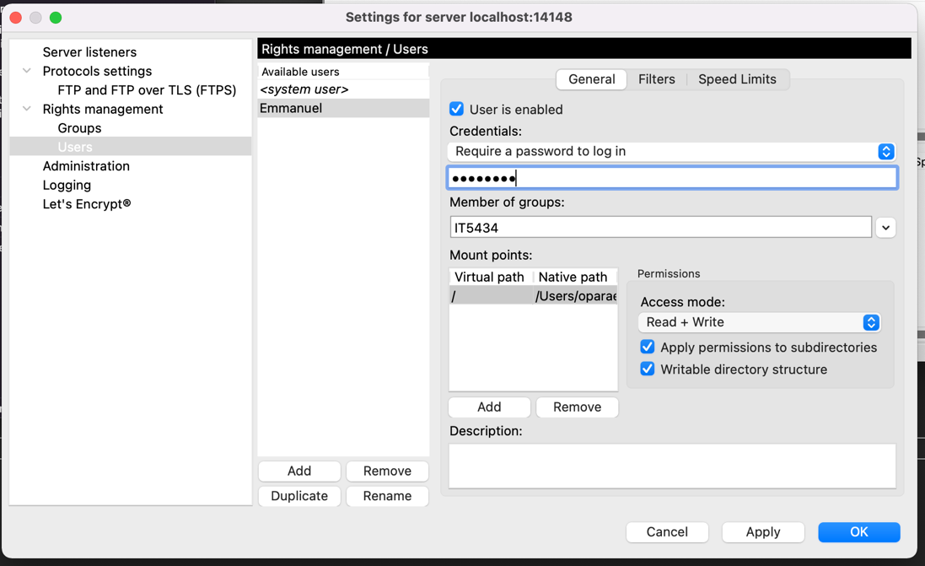

1. Go to <https://filezilla-project.org/download.php?platform=win64>, download and install (using the default settings) the latest version of FileZilla Client for Windows. While the server is still up and running, in the client enter the host address **ftpes://127.0.0.1** (since both the server and client are running on the same computer) with your created username and password (leaving the port number blank). Once successfully connected to your server, capture screenshot of your client, and paste it below showing the status logs and the directories/files of your local site (left panel) and those of your “Remote” site (right panel that show the user’s directory on the server side). As you can imagine, in the real world, the client and server will likely be on different computers, and the local site then becomes the computer/laptop where your client software is running.

The screenshot shows a successful connection with the server.

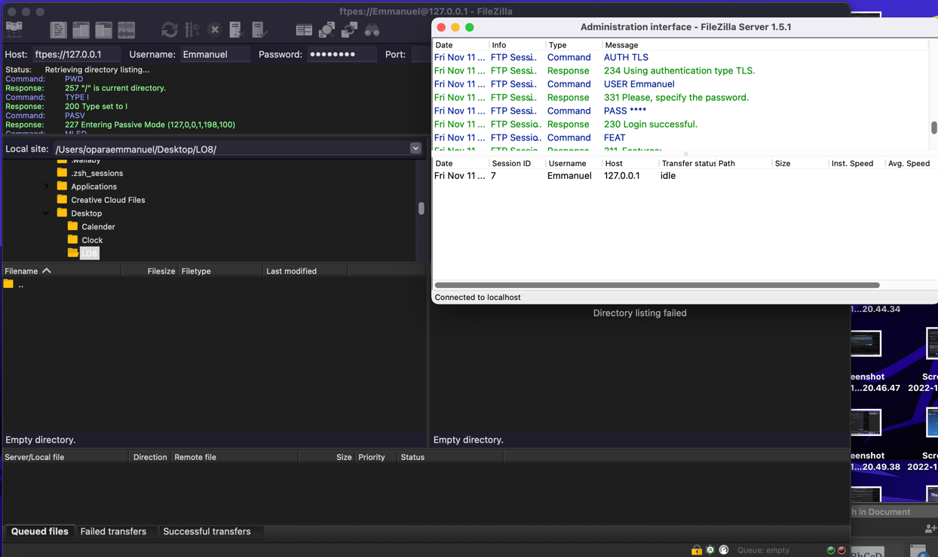

1. On your client, transfer a file between the local and remote sites. Then capture screenshot and paste it below to show the logs of successful transfer.

This screenshot shows the successfully transfer of files from the local site to the remote site when connected on the same server. If you look carefully at the bottom of the screenshot, you would see the successfully transferred files and the time of completion.

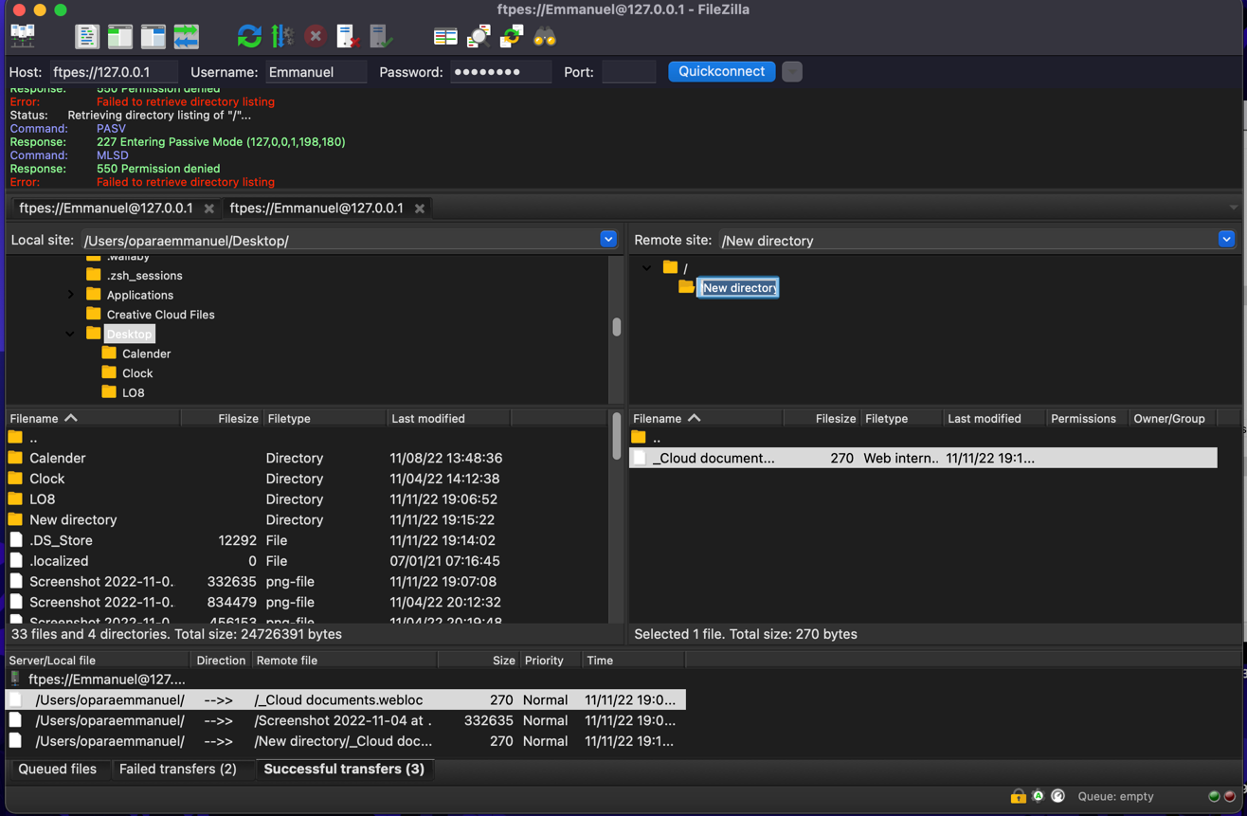

1. Go to your server and capture screenshot and paste it below showing server logs of successful connection.

The screenshot below shows the successful transfer of data between the local site and the New directory in the remote site.

